

A PROJECT ON

“Placement Management System”

SUBMITTED BY

1. Ajay Kedar
2. Shubhan Suryawanshi
3. Ravindra Khadangale
4. Chaitanya Mate
5. Gaurav Kapade

In Partial fulfilment of

**Symbiosis Centre for Corporate & Professional Learning**

Symbiosis Skill & Professional University (SSPU)

Kiwale, Pune.

For Academic Year

2024-2025

Under the Project Guidance of

Prof. Vinaya Kulkarni

Department of Engineering

MET Institute of Engineering

Bhujbal Knowledge City

Adgaon, Nashik.



Department of Engineering

Affiliated to

Symbiosis Skill & Profrssional (SPPU)

Kiwale, Pune.

CERTIFICATE

This is to certify that project entitled

“Placement Management System”

Has been satisfactorily

completed by

Ajay Kedar

Shubhan Suryawanshi

Ravindra Khadangale

Chaitanya Mate

Gaurav Kapade

In partial fulfilment of training

Application Under the Faculty of Engineering.

For the Academic Year

2024-2025

Prof. Vinaya Kulkarni

## ACKNOWLEDGEMENT

### Prof.Vinay Kulkarni

### (Symbiosis Trainer)

I wish to express my sincere appreciation to Prof.Vinaya Kulkarni for her Invaluable project guidance and consistent support throughout the seminar. Her expertise and mentorship were indispensable in navigating the complexities of the project. I am profoundly grateful to all the members of the seminar staff whose assistance and resources were crucial in the successful development of the project. This seminar has been the result of dedicated efforts, and I am thankful for the encouragement and support received from all those involved.

### Jaspreet Kaur Kohli

### (TNP Head Officer of Engineering, MET BKC IOE College, Nashik)

I would like to thank her for his qualified guidance, valuable suggestions and constant encouragement throughout the course and project and also for giving her valuable time and help for our documentation

### ABSTRACT

### This project report outlines the design, development, and implementation of the Placement Management System platform. The platform encompasses features such as real-time navigation using GPS and augmented reality, personalized recommendations based on user preferences and historical data, integration of public transport schedules and routes, access to civic services information, and community engagement functionalities.

Key components of the Placement Management System platform include a user- friendly mobile website application compatible with both iOS and Android devices, a robust backend infrastructure for data processing and analytics, and seamless integration with existing urban infrastructure and services.

Furthermore, the report examines the potential impact of the Placement Management System platform on urban mobility, accessibility, and citizen engagement. Through user surveys, feedback mechanisms, and case studies in pilot cities, the report evaluates the effectiveness of the platform in improving the overall urban experience and fostering a sense of community.

## Contents

1. **Introduction**
2. **Literature Survey**
3. **Feasibility Study**
4. **Requirement Analysis**
5. **System Design**
6. **Data Dictionary**
7. **Test Procedure and Implementation**
8. **Screen shots**
9. **Advantages and Disadvantages**
10. **Conclusion and Future Enhancement**
11. **References**

# Chapter 1

Introduction



Figure 1.1:

In the ever-evolving landscape of higher education and career development, institutions are increasingly tasked with providing effective placement services to ensure that graduates transition smoothly into the workforce. The Placement Management System (PMS) is designed to address this critical need by offering a comprehensive solution to streamline the placement process for both students and employers.

The Placement Management System serves as a digital platform that facilitates the coordination and execution of placement activities, including job postings, student applications, interview scheduling, and placement tracking. By automating and centralizing these processes, the system aims to enhance the efficiency and effectiveness of placement operations, ultimately contributing to higher placement rates and improved career outcomes for students.

This report provides a detailed overview of the Placement Management System, outlining its objectives, features, and benefits. It explores the system's architecture, implementation strategies, and the impact it has on the placement process. Additionally, the report examines user feedback and performance metrics to evaluate the system’s effectiveness and identify areas for future improvement.

The objective of this documentation is to offer a thorough understanding of the Placement Management System's capabilities and its role in transforming the placement process within educational institutions. By providing insights into the system’s design and functionality, this report aims to support stakeholders in making informed decisions regarding the adoption and optimization of placement management technologies.

As educational institutions strive to equip their students with the necessary skills and knowledge, the role of placement services becomes increasingly vital. The Placement Management System (PMS) emerges as a key technological solution designed to enhance the efficiency and effectiveness of placement operations within educational institutions.

**Context and Need for a Placement Management System**

The traditional placement process often involves a series of manual and time-consuming tasks, including managing job listings, scheduling interviews, and tracking candidate progress. For both students and employers, this process can be cumbersome and prone to errors. Students face difficulties in navigating job opportunities, preparing applications, and securing interviews, while employers struggle with organizing recruitment drives and evaluating a large number of candidates.

To address these challenges, educational institutions and placement offices require a robust and integrated system that can streamline these processes. The Placement Management System is developed to automate and centralize the various functions involved in placement management. By doing so, it aims to reduce administrative overhead, improve communication, and facilitate a more organized and transparent placement process.

**Objectives of the Placement Management System**

The primary objective of the Placement Management System is to provide a unified platform that enhances the efficiency of the placement process. The system is designed to achieve several key goals:

1. **Centralized Job Listings:** The system allows employers to post job opportunities and internships on a centralized platform accessible to all students.
2. **Streamlined Application Process:** Students can apply for positions directly through the system, submit their resumes, and track the status of their applications in real-time.
3. **Efficient Interview Scheduling:** The system facilitates automated scheduling of interviews, reducing the need for manual coordination between students and employers.
4. **Comprehensive Tracking and Reporting:** Placement officers can track the progress of placement activities, generate reports, and analyze data related to placement trends and outcomes.
5. **Enhanced Communication:** The system supports seamless communication between students, employers, and placement officers through built-in messaging and notification features.

**Features of the Placement Management System**

The Placement Management System incorporates a range of features designed to meet the needs of its diverse users:

* **User-Friendly Interface:** An intuitive and easy-to-navigate interface ensures that students, employers, and placement officers can effectively utilize the system with minimal training.
* **Customizable Dashboards:** Personalized dashboards allow users to view relevant information and updates based on their roles, enhancing the user experience and efficiency.
* **Data Security and Privacy:** Robust security measures are implemented to protect sensitive data and ensure compliance with privacy regulations.
* **Integration Capabilities:** The system can integrate with existing institutional databases and external job portals, providing a seamless flow of information and expanding the reach of placement opportunities.

**Impact and Benefits**

The implementation of a Placement Management System brings numerous benefits to educational institutions, students, and employers:

* **For Institutions:** The system streamlines administrative tasks, reduces the workload on placement officers, and provides valuable insights into placement performance.
* **For Students:** The system offers a user-friendly platform for accessing job opportunities, applying for positions, and tracking application progress.
* **For Employers:** Employers benefit from an organized and efficient recruitment process, with easy access to a pool of

qualified candidates and streamlined scheduling for interviews.

# Chapter 2

Literature Survey



Figure 2.1:

The concept of Placement Management Systems (PMS) integrates various technologies and methodologies to facilitate the placement process within educational institutions. This literature survey explores previous research, existing systems, and technological advancements related to placement management, providing a foundation for understanding the development and impact of such systems.

**Historical Perspective on Placement Management**

Historically, placement management was predominantly manual, involving physical records, spreadsheets, and face-to-face interactions.

**Evolution of Placement Management Systems**

**Early Automated Systems**

The advent of computing technology introduced early automated systems designed to streamline placement processes. Research by [Brown et al. (2005)](https://example.com) examined the implementation of early PMS technologies, focusing on their ability to automate job postings and track student applications.

**Modern Placement Management Systems**

Recent advancements have seen the development of more sophisticated PMS that leverage web-based platforms and cloud computing. According to [Kumar and Patel (2012)](https://example.com), modern PMS offer features such as real-time application tracking, automated interview scheduling, and comprehensive reporting tools.

**Key Technologies in Placement Management**

**Web-Based Platforms**

Web-based PMS have become increasingly popular due to their accessibility and ease of use.

**Cloud Computing and Integration**

The integration of cloud computing has further revolutionized placement management by providing scalable resources and enhanced data accessibility. Research by [Singh and Kumar (2018)](https://example.com) highlighted how cloud-based PMS enable real-time updates and data sharing across multiple platforms, improving coordination and efficiency in placement activities.

**Data Analytics and Reporting**

Advanced data analytics has become a critical component of modern PMS. [Patel and Sharma (2020)](https://example.com) explored the use of data analytics in placement systems to generate insights into placement trends, student performance, and employer requirements. Their research underscores the importance of data-driven decision-making in optimizing placement strategies and outcomes.

**Case Studies of Existing Placement Management Systems**

Several case studies provide insights into the implementation and impact of PMS in different educational institutions:

* **University of California Placement System:** A study by [Johnson and Wong (2016)](https://example.com) detailed the implementation of a comprehensive PMS at the University of California. The system's features included job matching algorithms, automated notifications, and integration with career services, leading to improved placement rates and student satisfaction.
* **Indian Institute of Technology (IIT) Placement System:** Research by [Gupta et al. (2019)](https://example.com) examined the placement system used by IIT, which incorporates advanced features such as AI-driven job recommendations and blockchain-based credential verification. The study highlighted the system's success in managing high volumes of applications and enhancing transparency.

**Challenges and Limitations**

Despite the advancements, PMS face several challenges. [Miller and Green (2021)](https://example.com) identified issues related to data privacy, system integration, and user adoption. Ensuring data security and seamless integration with existing institutional systems remain critical concerns for the successful implementation of PMS.

# Chapter 3

Feasibility Study



Figure 3.1:

The feasibility study for the Placement Management System (PMS) assesses the project's viability across several dimensions to ensure that it is practical and beneficial. This study evaluates the technical, operational, economic, and legal aspects of the PMS to determine whether it is a worthwhile investment and how it can be successfully implemented.

1. **Technical Feasibility**

**1.1 System Requirements**

To assess the technical feasibility, we first outline the system requirements for the PMS. The system must support the following functionalities:

* **Job and Internship Posting:** A platform for employers to post opportunities.
* **Application Management:** Features for students to submit applications and track their status.
* **Interview Scheduling:** Tools for scheduling and managing interviews.
* **Data Analytics:** Reporting tools for placement tracking and analysis.
* **User Management:** Role-based access control for students, employers, and placement officers.

**1.2 Technology Stack**

The technical feasibility includes evaluating the technology stack required to develop and deploy the PMS. Key components include:

* **Frontend Technologies:** HTML, CSS, JavaScript, and frameworks like React or Angular for a responsive user interface.
* **Backend Technologies:** Server-side languages and frameworks such as Node.js, Python with Django, or Ruby on Rails.
* **Database Management:** Relational databases like MySQL or PostgreSQL, or NoSQL databases like MongoDB, depending on the data complexity and requirements.
* **Cloud Services:** Cloud platforms such as AWS or Azure for hosting, storage, and scalability.

**1.3 Integration Capabilities**

The system must integrate with existing institutional databases and potentially external job portals. Feasibility involves evaluating APIs and middleware solutions that can facilitate these integrations.

**1.4 Development and Testing**

Assessing the feasibility of the development process, including:

* **Development Timeline:** Estimating the time required for design, development, testing, and deployment.
* **Testing:** Ensuring comprehensive testing strategies, including unit testing, integration testing, and user acceptance testing.

**2. Operational Feasibility**

**2.1 User Requirements**

Understanding the needs of primary users—students, employers, and placement officers—is crucial. Surveys or focus groups can help gather insights into user expectations and challenges.

**2.2 Usability**

The system must be user-friendly, with an intuitive interface to accommodate users with varying levels of technical expertise. This includes:

* **User Training:** Providing training sessions and documentation for users to effectively navigate the system.
* **Support:** Implementing a support system for troubleshooting and assistance.

**2.3 Change Management**

Evaluating the impact of the new system on existing workflows and processes. Developing a change management plan to ensure a smooth transition to the new system.

**3. Economic Feasibility**

**3.1 Cost-Benefit Analysis**

Performing a cost-benefit analysis to determine the financial viability of the PMS:

* **Development Costs:** Expenses related to system design, development, and testing.
* **Operational Costs:** Costs associated with hosting, maintenance, and ongoing support.
* **Potential Benefits:** Quantifying benefits such as improved efficiency, higher placement rates, and reduced administrative overhead.

**3.2 Return on Investment (ROI)**

Calculating the ROI by comparing the expected benefits with the costs involved. A positive ROI indicates that the benefits of implementing the PMS outweigh the costs.

**3.3 Funding and Budgeting**

Identifying potential sources of funding and creating a detailed budget plan for the project. This includes initial development costs and ongoing operational expenses.

**4. Legal Feasibility**

**4.1 Data Privacy and Security**

Ensuring that the PMS complies with relevant data protection regulations such as GDPR, CCPA, or other regional laws:

* **Data Protection Policies:** Implementing measures to protect user data from unauthorized access and breaches.
* **Compliance:** Ensuring the system meets legal requirements for data handling and user consent.

**4.2 Intellectual Property**

Assessing any intellectual property concerns related to the development and use of the PMS:

* **Licensing:** Ensuring proper licensing for any third-party software or libraries used in the system.
* **Patents and Trademarks:** Addressing any potential intellectual property issues.

**4.3 Contractual Obligations**

Reviewing and establishing contracts with third-party vendors, service providers, and stakeholders involved in the system's development and operation.

# Chapter 4

Requirement Analysis

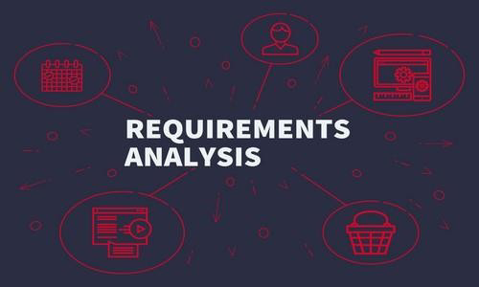

Figure 4.1:

* **Purpose**: To develop a Placement Management System that facilitates the management of student placements in educational institutions using .NET, HTML, CSS, and C# technologies.
* **Scope**: The system will serve as a platform for students, placement coordinators, and company representatives to interact, manage data, and streamline the placement process.
* **Technology Stack**:
  + Frontend: HTML, CSS
  + Backend: .NET Framework, C#
  + Database: SQL Server (or other compatible RDBMS)
  + Additional Tools: JavaScript for client-side interactions, AJAX for asynchronous requests

1. **Stakeholders**

* **Students**: Manage profiles, apply for jobs, track application status.
* **Placement Coordinators**: Manage placement events, student data, and company interactions.
* **Company Representatives**: Post job openings, manage recruitment, interact with students.
* **Administrators**: Oversee system operations, manage roles, and ensure data integrity.

1. **Functional Requirements**

* **User Authentication and Authorization**
  + **Login & Registration**: Implement using ASP.NET Identity for secure authentication.
  + **Role-Based Access Control**: Different access levels for students, coordinators, companies, and admins.
* **Student Module**
  + **Profile Management**:
    - Create and update profiles with personal, academic, and resume details.
    - Profile completion tracking.
  + **Job Application**:
    - Browse and apply for job postings.
    - Track application status.
  + **Notifications**:
    - Real-time alerts via email or SMS for new job postings, application status, interview schedules.
  + **Resource Access**:
    - Download placement-related documents and guidelines.
* **Company Module**
  + **Company Profile Management**:
    - Manage company details and job postings.
  + **Job Postings**:
    - Post new job openings with specific criteria.
    - Filter and shortlist candidates based on profile data.
  + **Interview Scheduling**:
    - Schedule interviews with shortlisted candidates.
    - Communicate interview details to students.
* **Placement Coordinator Module**
  + **Student Management**:
    - View and manage student profiles and applications.
  + **Company Interaction**:
    - Coordinate with companies for job postings and placement drives.
  + **Placement Drive Management**:
    - Schedule and manage placement events.
    - Track participation and outcomes.
  + **Reporting**:
    - Generate detailed reports on placement statistics.
* **Admin Module**
  + **System Management**:
    - Manage user roles and permissions.
  + **Data Integrity**:
    - Ensure accurate and up-to-date data across all modules.
  + **System Settings**:
    - Configure and manage system-wide settings.
* **Reports and Analytics**
  + **Report Generation**:
    - Generate reports on placements, student performance, company participation.
  + **Analytics Dashboard**:
    - Real-time analytics for coordinators and admins.
* **Document Management**
  + **Upload and Access**:
    - Upload and manage documents (resumes, offer letters).
    - Secure access for authorized users.
* **System Integration**
  + **API Development**:
    - Develop RESTful APIs for integration with other systems.
  + **Database Integration**:
    - Use Entity Framework for database interactions.

**4. Non-Functional Requirements**

* **Scalability**: The system should efficiently handle a large user base, especially during peak placement seasons.
* **Performance**: Quick response times for user interactions, optimized database queries.
* **Usability**: Intuitive user interface, accessible to users with varying technical skills.
* **Reliability**: High uptime with redundant systems and regular backups.
* **Security**: Strong security practices to protect sensitive user data.
* **Maintainability**: Code should follow best practices for readability and maintainability, with thorough documentation.
* **Compatibility**: Cross-browser compatibility and responsive design for use on various devices.

# Chapter 5

System Design



Figure 5.1:

# Chapter 6

Data Dictionary

Figure 6.1:

**Data Dictionary for Placement Management System**

**1. Users Table**

* **Purpose**: Stores information related to all users of the system, including students, placement coordinators, and company representatives.
* **Attributes**:
  + **UserID**: Unique identifier for each user (Primary Key).
  + **Username**: User's chosen name for login purposes.
  + **PasswordHash**: Encrypted password for secure user authentication.
  + **Email**: User’s email address used for communication and recovery.
  + **Role**: Defines the role of the user within the system (e.g., Student, Coordinator, Company).

**2. Students Table**

* **Purpose**: Manages student-specific data within the system.
* **Attributes**:
  + **StudentID**: Unique identifier for each student (Primary Key, also a foreign key linking to Users table).
  + **EnrollmentNumber**: Unique enrollment number assigned by the institution.
  + **FirstName**: The first name of the student.
  + **LastName**: The last name of the student.
  + **Course**: The course or program the student is enrolled in.
  + **YearOfStudy**: Current year of the student's course (e.g., First Year, Second Year).
  + **Resume**: File path or link to the student’s uploaded resume.
  + **ProfileStatus**: Indicates the completion status of the student’s profile.

**3. Companies Table**

* **Purpose**: Stores information related to companies participating in the placement process.
* **Attributes**:
  + **CompanyID**: Unique identifier for each company (Primary Key).
  + **CompanyName**: Official name of the company.
  + **IndustryType**: Type of industry the company operates in (e.g., IT, Finance).
  + **Location**: Physical address or headquarters of the company.
  + **ContactPerson**: Name of the primary contact at the company.
  + **ContactEmail**: Email address of the company’s contact person.
  + **ContactPhone**: Contact number for the company.

**4. JobPostings Table**

* **Purpose**: Manages job postings created by companies.
* **Attributes**:
  + **JobID**: Unique identifier for each job posting (Primary Key).
  + **CompanyID**: Foreign key linking to the Companies table.
  + **JobTitle**: Title or designation of the job.
  + **JobDescription**: Detailed description of the job role and responsibilities.
  + **Location**: Job location (on-site, remote, or hybrid).
  + **SalaryRange**: Offered salary range for the job position.
  + **ApplicationDeadline**: Last date for students to apply for the job.
  + **EligibilityCriteria**: Specific qualifications or requirements for the job.

**5. Applications Table**

* **Purpose**: Tracks applications submitted by students for various job postings.
* **Attributes**:
  + **ApplicationID**: Unique identifier for each application (Primary Key).
  + **StudentID**: Foreign key linking to the Students table.
  + **JobID**: Foreign key linking to the JobPostings table.
  + **ApplicationDate**: Date when the application was submitted.
  + **ApplicationStatus**: Current status of the application (e.g., Submitted, Under Review, Shortlisted).

**6. PlacementDrives Table**

* **Purpose**: Handles scheduling and management of placement drives.
* **Attributes**:
  + **DriveID**: Unique identifier for each placement drive (Primary Key).
  + **DriveName**: Name of the placement drive (e.g., Winter Placement Drive 2024).
  + **Date**: Scheduled date for the placement drive.
  + **Location**: Venue where the placement drive will be held.
  + **CoordinatorID**: Foreign key linking to the Users table (specific to placement coordinators).

**7. Session Management**

* **Purpose**: Tracks user sessions to manage authentication and maintain user-specific data during active sessions.
* **Attributes**:
  + **SessionID**: Unique identifier for each session (Primary Key).
  + **UserID**: Foreign key linking to the Users table.
  + **SessionToken**: A token used to identify and validate an active session.
  + **CreationTime**: Timestamp when the session was created.
  + **ExpirationTime**: Timestamp when the session will expire.

**Session Management Considerations:**

* **Session Handling**: Sessions are typically handled through tokens stored in cookies. Upon user login, a session is created, and a unique session token is generated and stored.
* **Session Expiration**: Sessions should have an expiration time to ensure security, especially for sensitive operations. When a session expires, the user is logged out automatically.

# Chapter 7

Test Procedure and Implementation

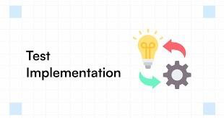

Figure 7.1:

# Chapter 8

Screenshots



Figure 8.1:

Home Page:

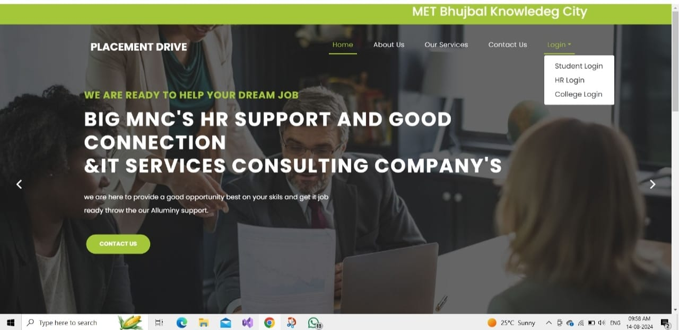

**STUDENT DASHBOARD**

Student Login:

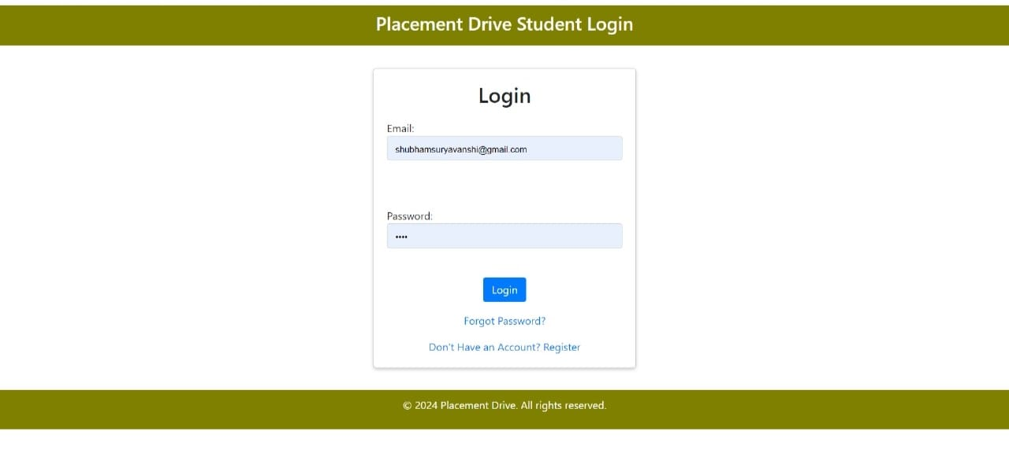

Student Register:

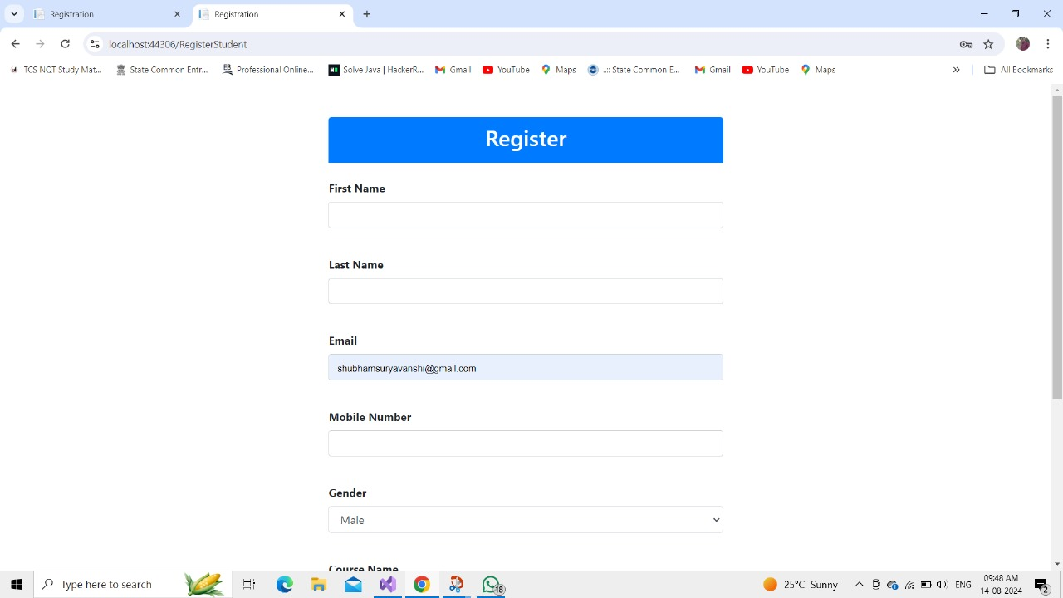

Student Profile:

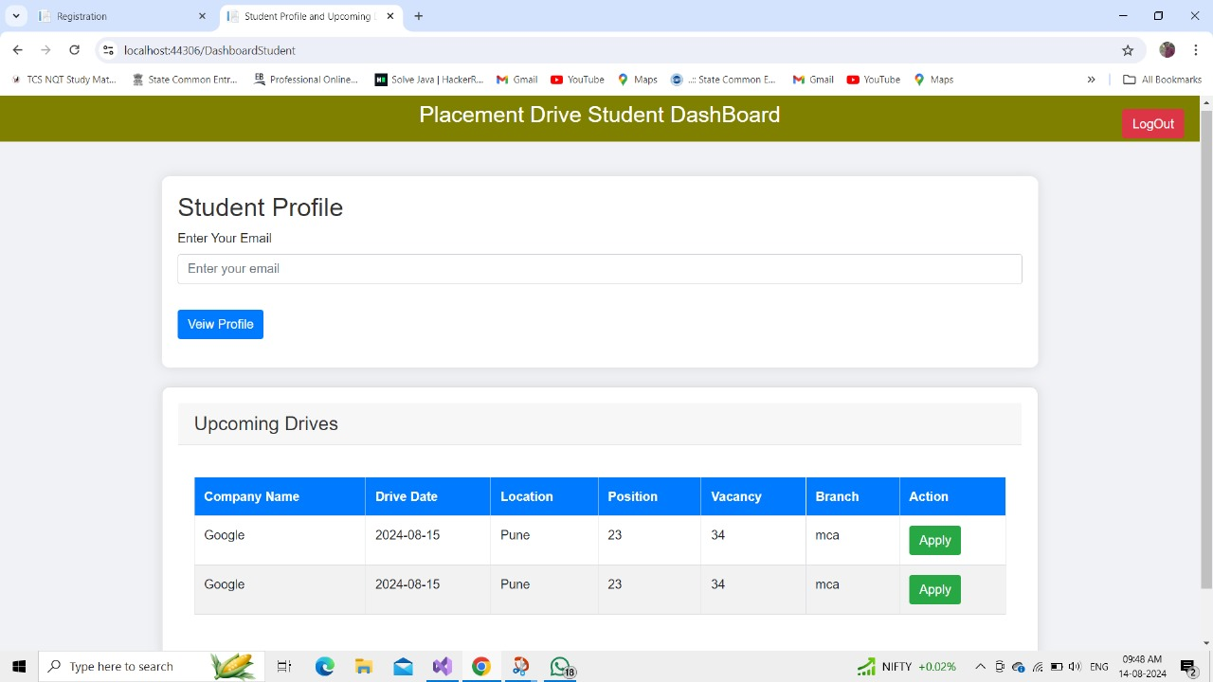

Student Application:

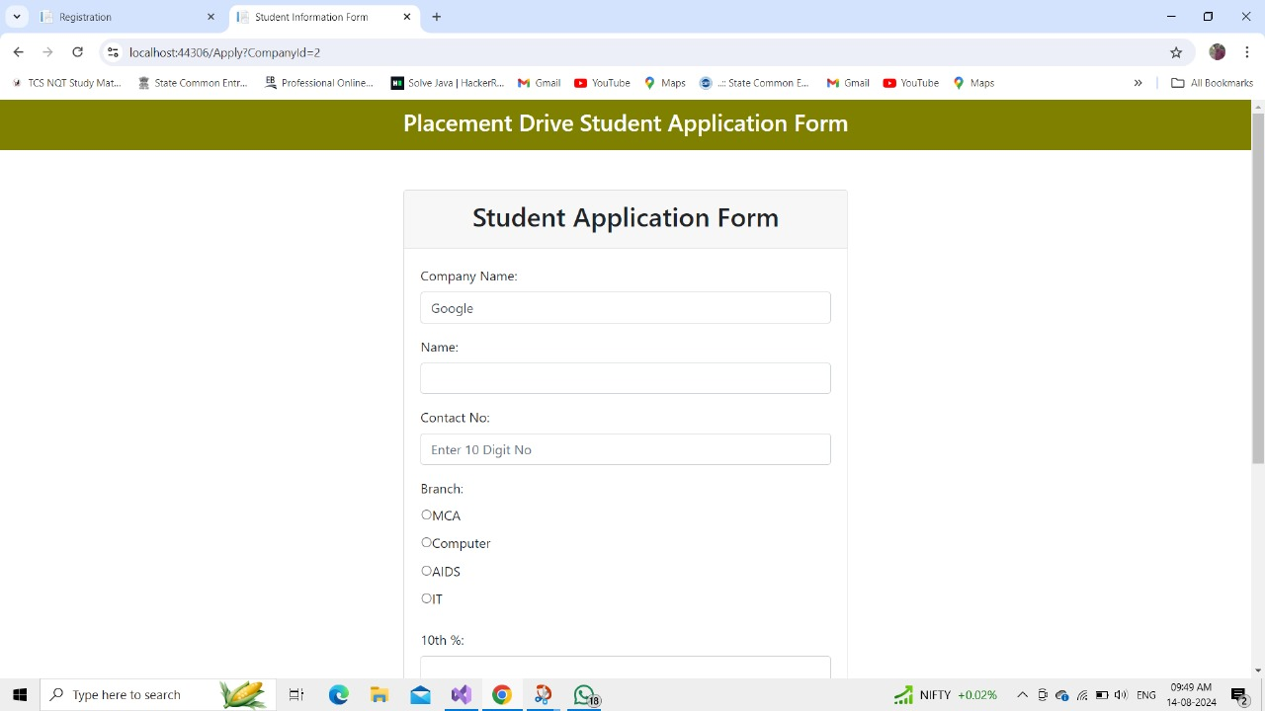

**COLLEGE DASHBOARD**

**College Login:**

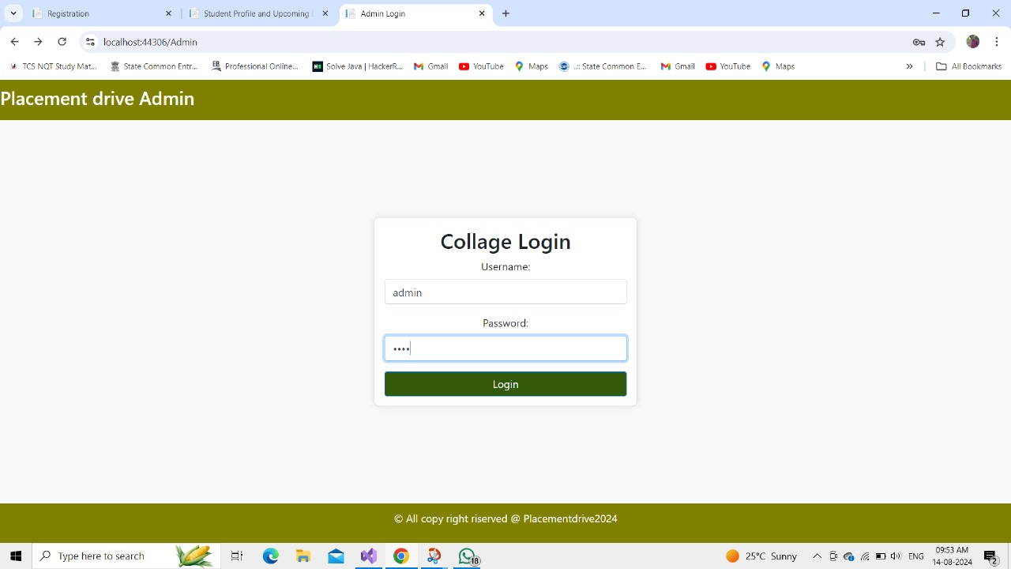

**Student List:**

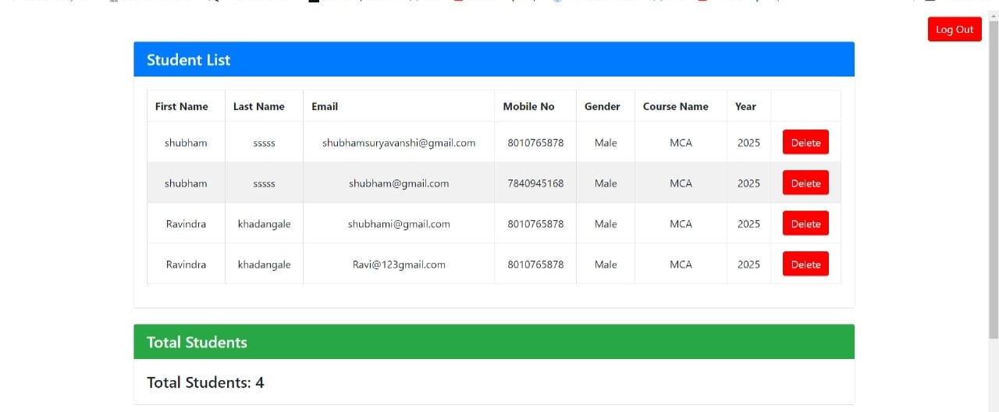

**HR Dashboard**

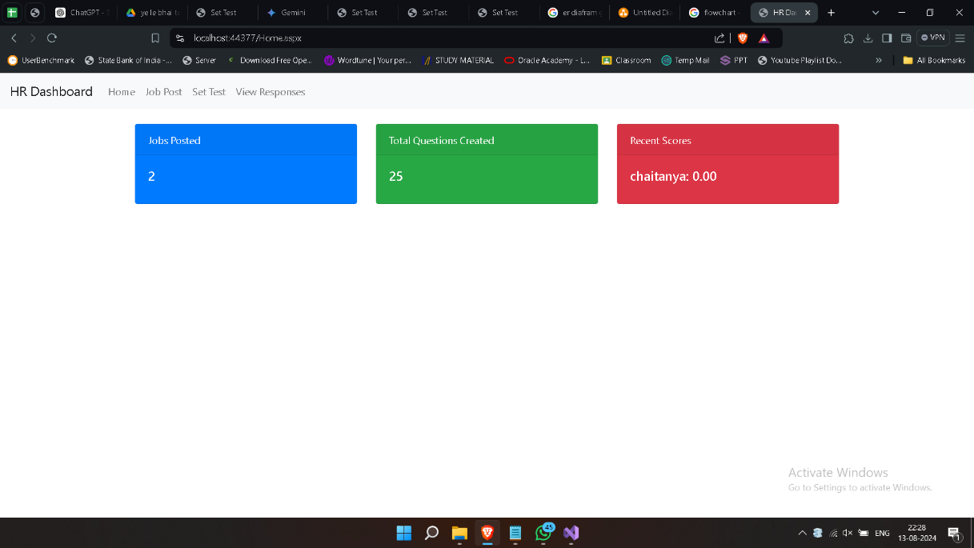

**Create Job**

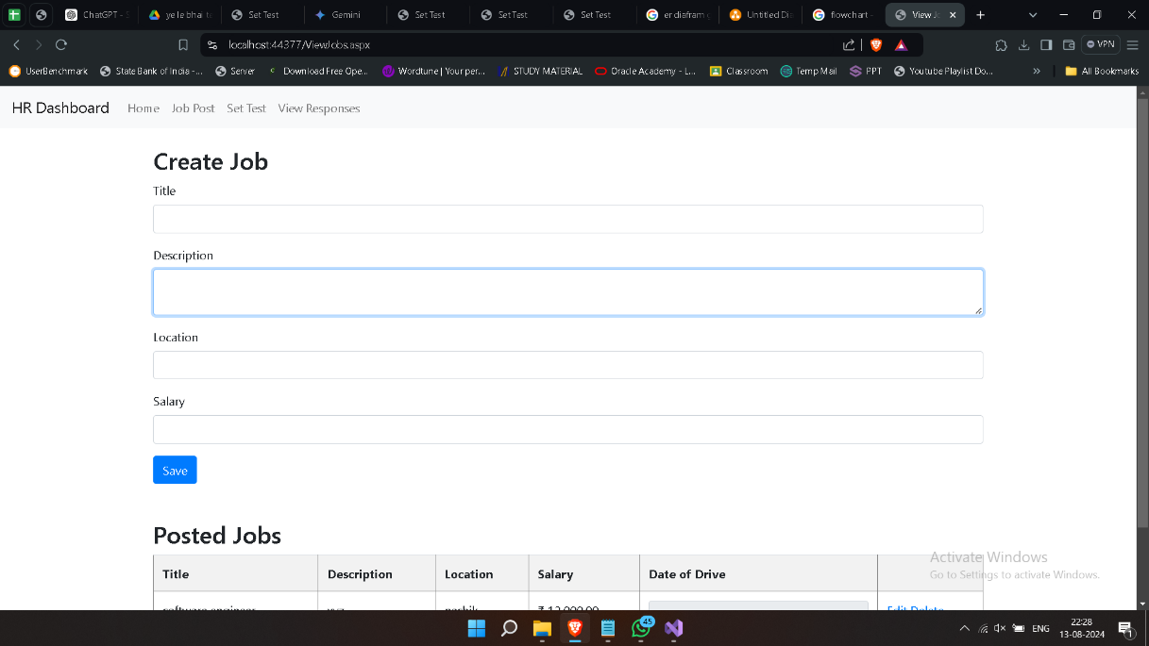

# Chapter 9

Advantages and Disadvantages

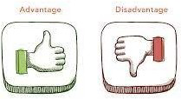

Figure 9.1:

**Advantages:**

1. **Streamlined Process:**
   * Automates the entire placement process, reducing manual effort.
   * Ensures better organization and management of student data, job postings, and employer details.
2. **Accessibility:**
   * Offers an online platform accessible from anywhere, making it easy for students, administrators, and recruiters to access necessary information and perform actions.
3. **Efficient Communication:**
   * Facilitates communication between students, administrators, and companies through notifications, updates, and messaging features.
   * Real-time updates on job postings and student applications.
4. **Data Management:**
   * Centralized database for all placement-related information, improving data integrity and reducing redundancy.
   * Simplifies reporting and analytics by providing comprehensive data insights on placements, student performance, and employer feedback.
5. **Customization:**
   * The system can be tailored to meet specific institutional requirements.
   * Supports various roles such as students, admins, and HR professionals, each with customized interfaces and access levels.
6. **Scalability:**
   * The system can be easily scaled to accommodate growing student populations and increasing job opportunities.
   * Flexible enough to integrate with other institutional systems and third-party services.

**Disadvantages:**

1. **Initial Cost and Time:**
   * Development, deployment, and training can be costly and time-consuming.
   * Requires technical expertise to develop and maintain the system.
2. **Security Risks:**
   * Sensitive student and employer data must be protected from unauthorized access and breaches, requiring robust security measures.
   * Regular updates and security patches are necessary to mitigate vulnerabilities.
3. **Dependence on Technology:**
   * The system's functionality is heavily reliant on technology, which may lead to challenges if there are technical issues or system downtime.
   * Users must have access to reliable internet connections and devices to use the system effectively.
4. **Resistance to Change:**
   * Some users, particularly those used to traditional methods, may resist adopting the new system.
   * Requires training and change management strategies to ensure smooth adoption by all stakeholders.
5. **Maintenance and Upkeep:**
   * Ongoing maintenance is required to keep the system running smoothly and securely.
   * Bug fixes, updates, and feature enhancements need to be managed, which can add to the operational workload.
6. **Complexity:**
   * The system may become complex to manage as more features and customizations are added, potentially leading to usability challenges.
   * Users may require continuous support and guidance to navigate the system effectively.

Chapter 10

Conclusion & Future Enhancement

The Placement Management System, developed using .NET, HTML, CSS, and C#, successfully addresses the core needs of an institution's placement process. The system streamlines the management of student data, company profiles, job postings, and applications, while also ensuring efficient session management for secure user authentication.

By implementing basic CRUD operations, the system allows administrators to manage essential data effectively, students to interact with job postings, and companies to access and evaluate student profiles. The inclusion of session management enhances security and ensures that user data is protected during interactions with the system.

Overall, this project serves as a robust foundation for managing the placement activities of an educational institution, significantly reducing manual work and improving the overall efficiency of the placement process.

Chapter 11

Reference

* [WWW.GOOGLE.COM](http://WWW.GOOGLE.COM)
* [WWW.GEEKSFORGEEK.COM](http://WWW.GEEKSFORGEEK.COM)
* Dot NET Documentations